Insert your school’s name or logo here! | Alexandria Zoo  3016 Masonic Drive  Alexandria, LA 71301  318-441-6810  www.thealexandriazoo.com | 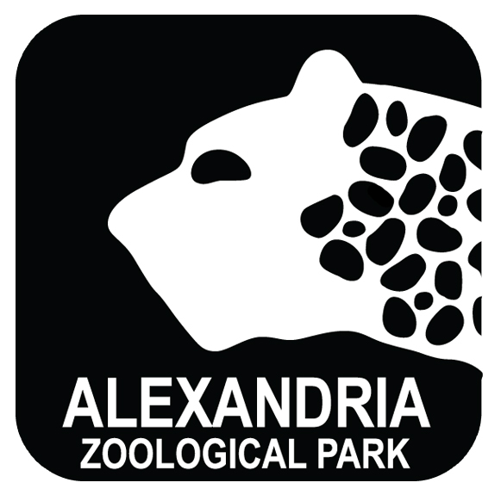

We’re going to Alexandria Zoo!

Your child’s class is going on a field trip to Alexandria Zoo. This opportunity will allow our students to interact with wildlife in a completely unique way and will help us enhance our current curriculum goals. As an accredited member of the Association of Zoos and Aquariums, Alexandria Zoo is the perfect setting for our students to discover the impact they can have on the world’s wildlife and wild places.

Date of Trip: | Departure Time: |  | Return Time:
Method of Travel: |  | Cost to Student: $
Cost Includes:  Admission  Train Ride  Transportation  Lunch  Gift Shop Souvenirs
Student Lunch:  Bring  Buy ($ )  Provided in Cost  Not Needed
This trip relates to our current studies:

Please complete and detach the bottom portion of this form and return to teacher with payment.
--------------------------------------------------------------------------------------------------------------------------------------------------------------
Student Information

Name of Student: _______________________________________________________________________________________

❑ I give permission for this student to attend a field trip to Alexandria Zoo on ________________________ (date).

In the event of an emergency, the following people should be contacted:

1. Name _________________________________________________ Number ______________________________
Relation to student: ____________________________________________________________________________
2. Name _________________________________________________ Number ______________________________
Relation to student: ____________________________________________________________________________
3. Name _________________________________________________ Number ______________________________
Relation to student: ____________________________________________________________________________
I have enclosed cash/check for the amount of: $ _______________ Please make check payable to:
❑ I do not give permission for this student to attend this field trip.

______________________________________________________________ _________________________________
Parent/Guardian Signature Date

